**07-05-22**

TODAYS AGENDA :-------

* Pytest
* Class work

*****************************************************************

**PYTEST**

Pytest is the module through which we can create tests for our application.

It is written in Python language.

It is used to test from Simple to Complex applications easily.

It is majorly used to test API’s although you can use it for any Python code.

**Advantages of Pytest over Python Unittest**

* It is very easy and simple to write
* We can even do parallel test using pytest but where as in python unit testing test, will be conducted one after the other i.e entire test
* It can run a specific test not all like Python unittest
* It saves us a lot of time
* It detects test cases very easily
* You can skip specific tests using Pytest
* It is open-source framework of Python

**Install Pytest**

pip install pytest

pytest --version

pytest –h === shows the pytest installed correctly and working

All test files should be named with **test_filename.py** or **filename_test.py**

**To run a Pytest** ;------ use the command at your command prompt / terminal

pytest <file_name> Eg:-- pytest test_suman.py

But, to get a detailed report of your test in cmd/terminal use the following command:-

pytest -v <file_name> Eg:-- pytest -v test_suman.py

pytest –v <file_name> <file_name> 🡪 this is to run 2 test files at 1 go

*********************************************************

Suman.py consist of all functions

Test_suman.py consist of all test cases functions

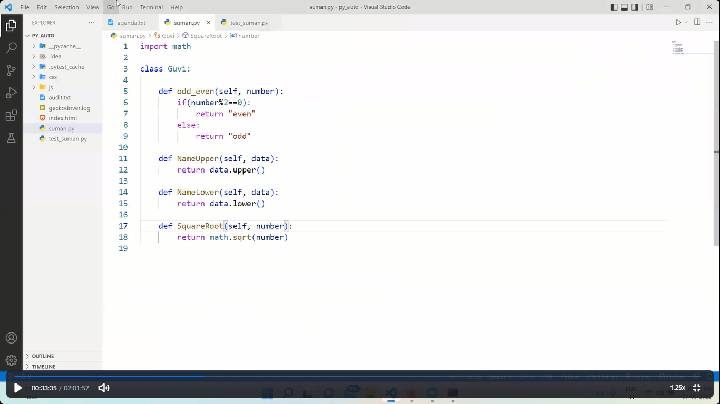

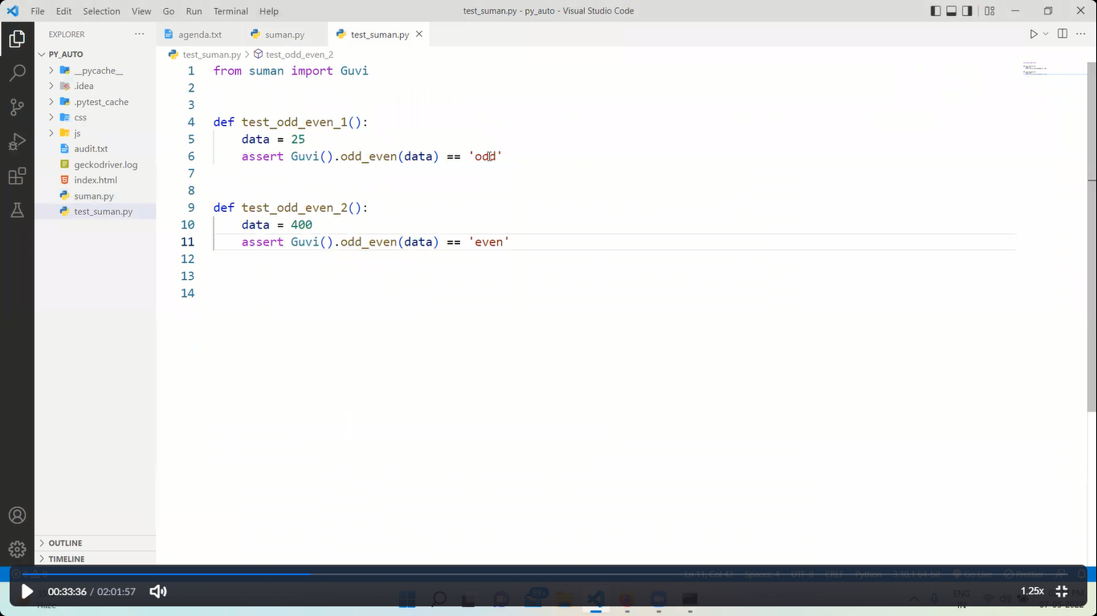

*************************************************************

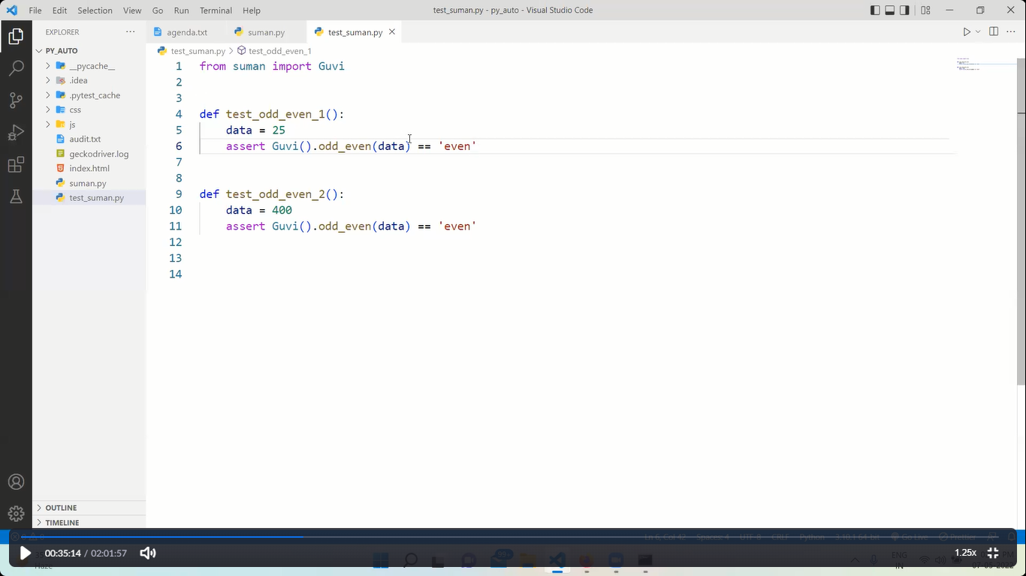

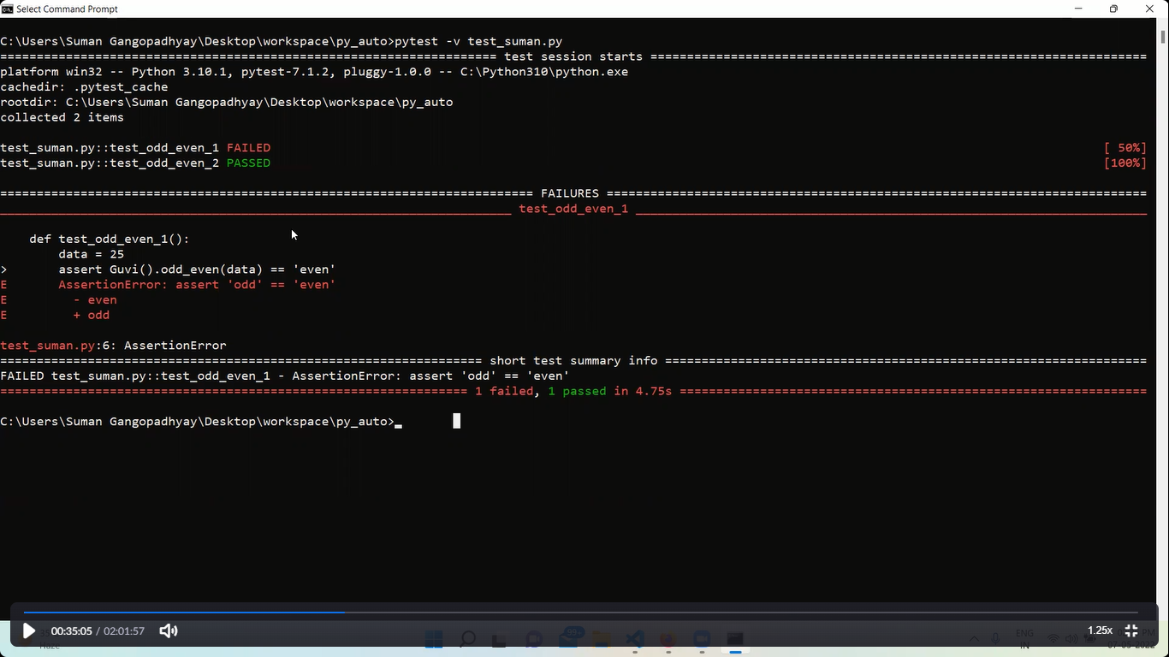

************************************************************

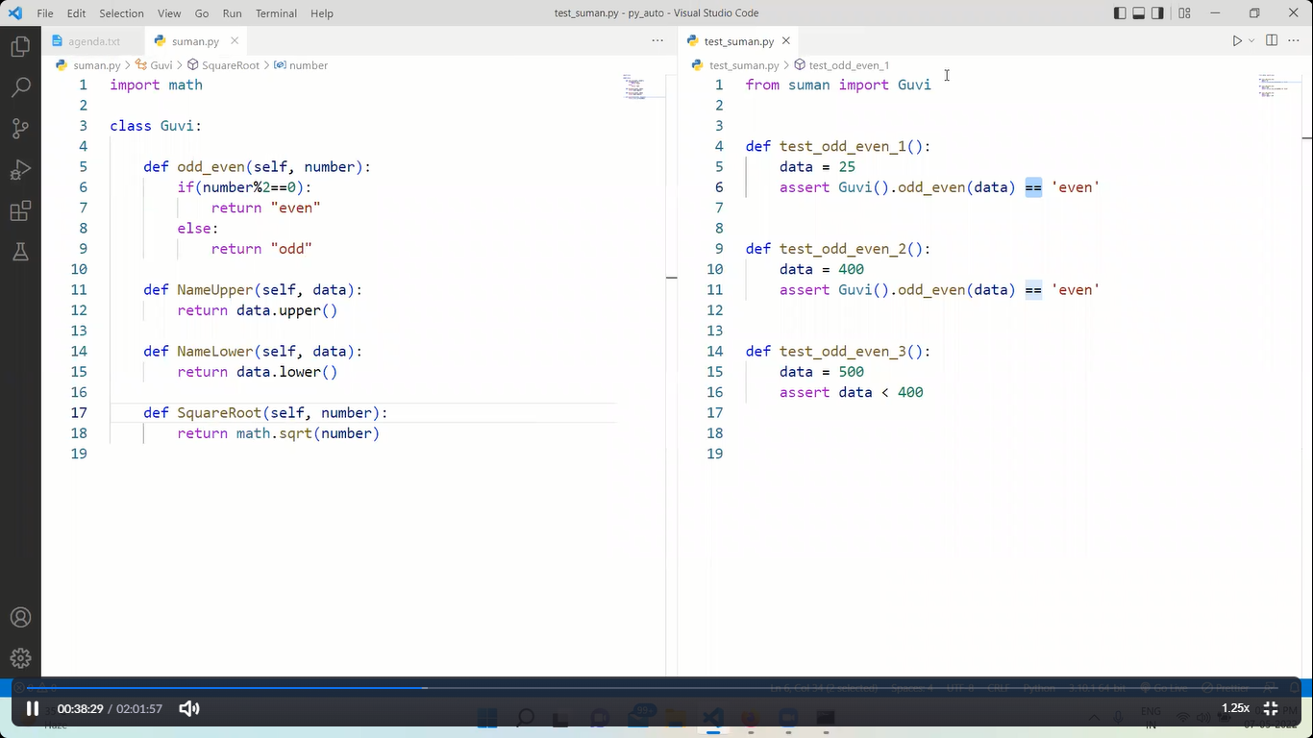

******************************************************

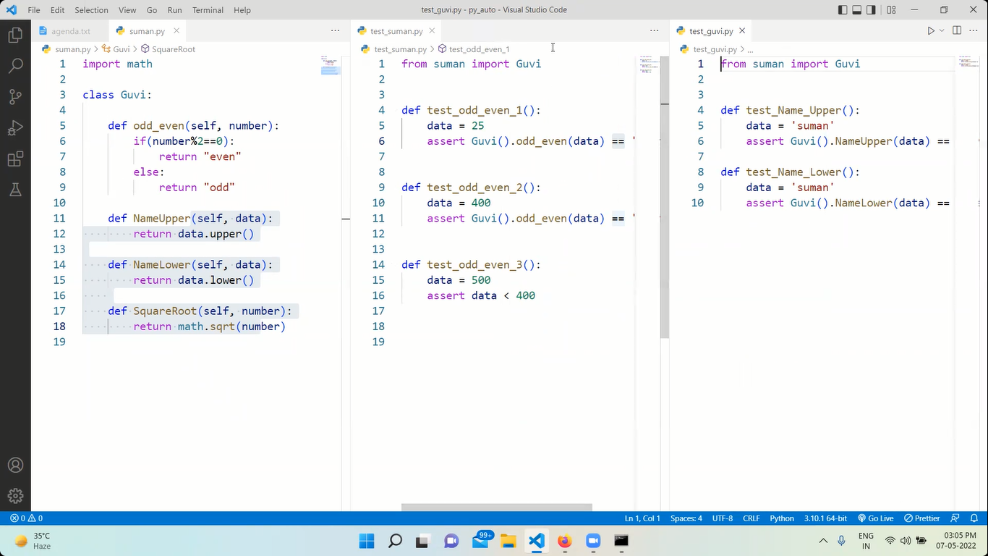

Running 2 test files at a time in cmd

Pytest –v test_guvi.py test_suman.py

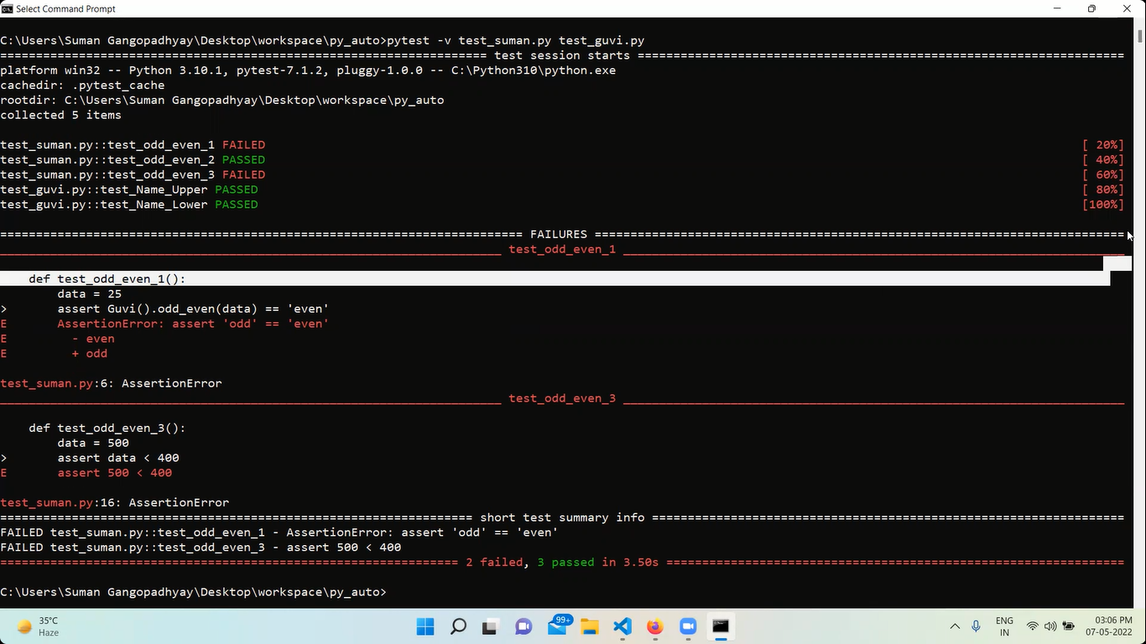

*********************************************************

**Markers:----**

Markers are nothing but by using markers we can control which **test_function** should run from the **test_file**

For that we need to create a **pytest.ini** file & should mention which marker should run

pytest.ini 🡪 should be created in the same folder

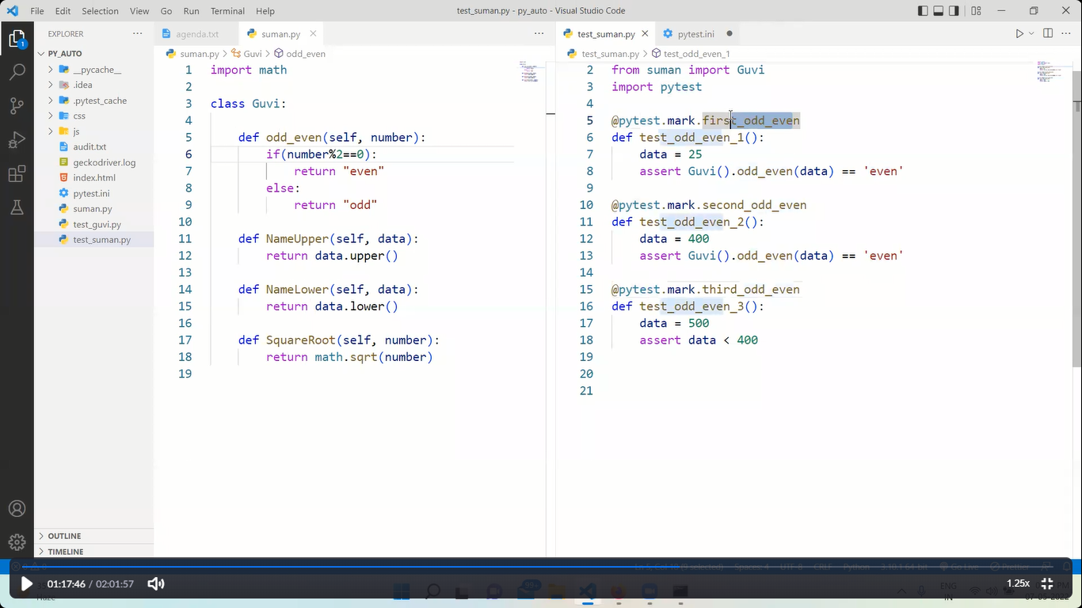

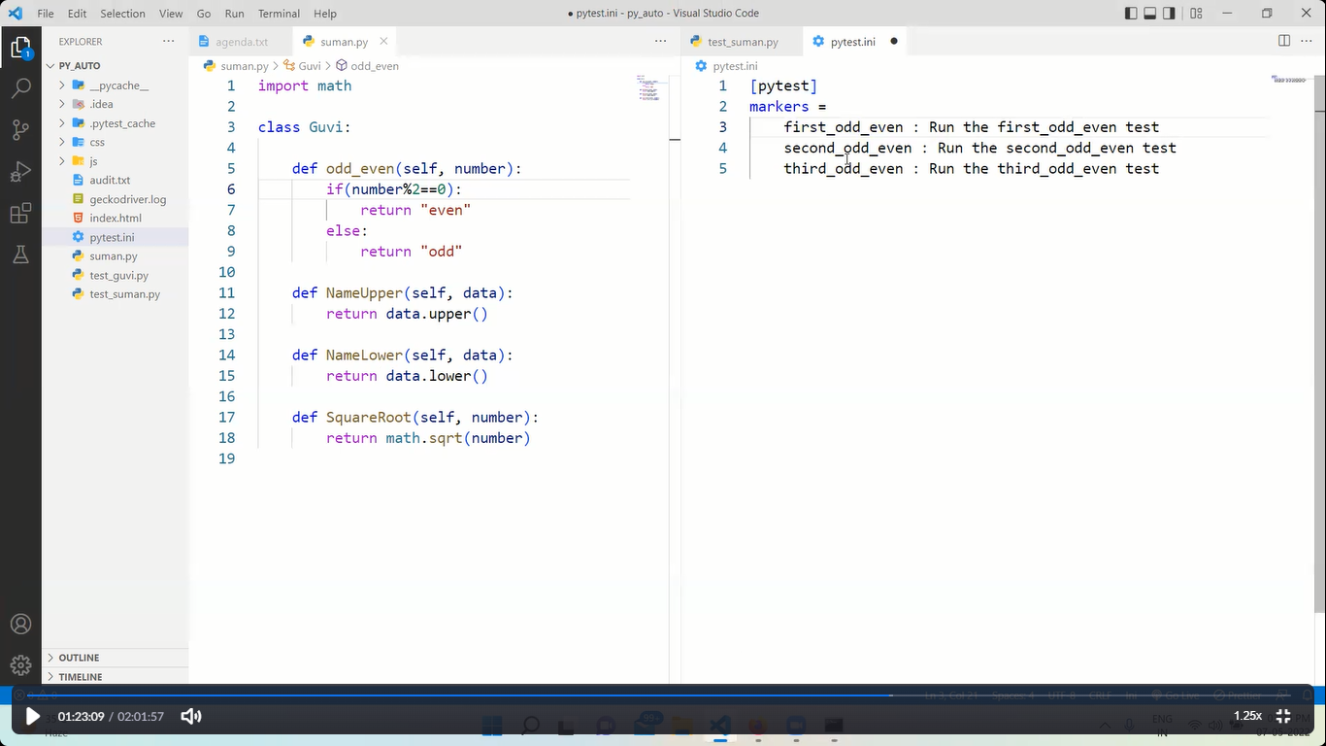

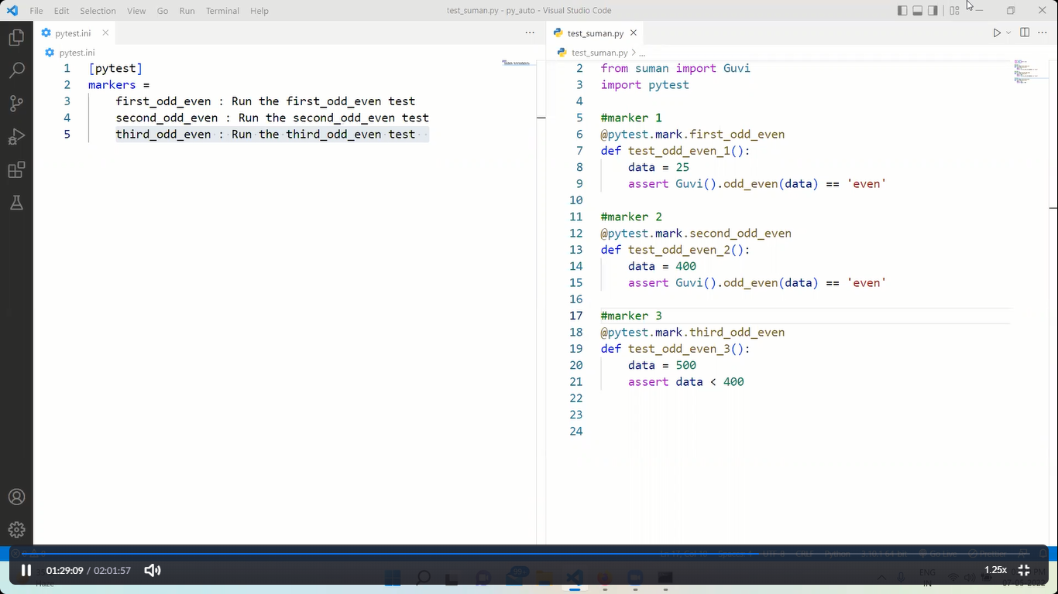

**OR**

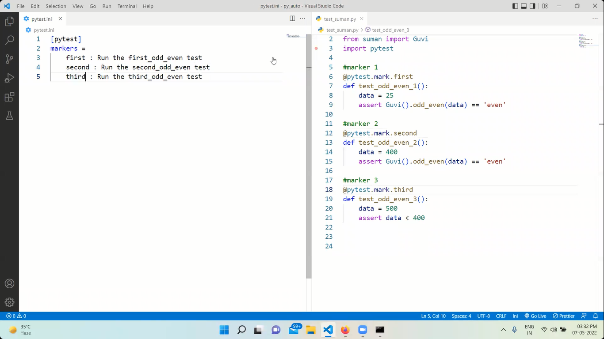

*******************************************************

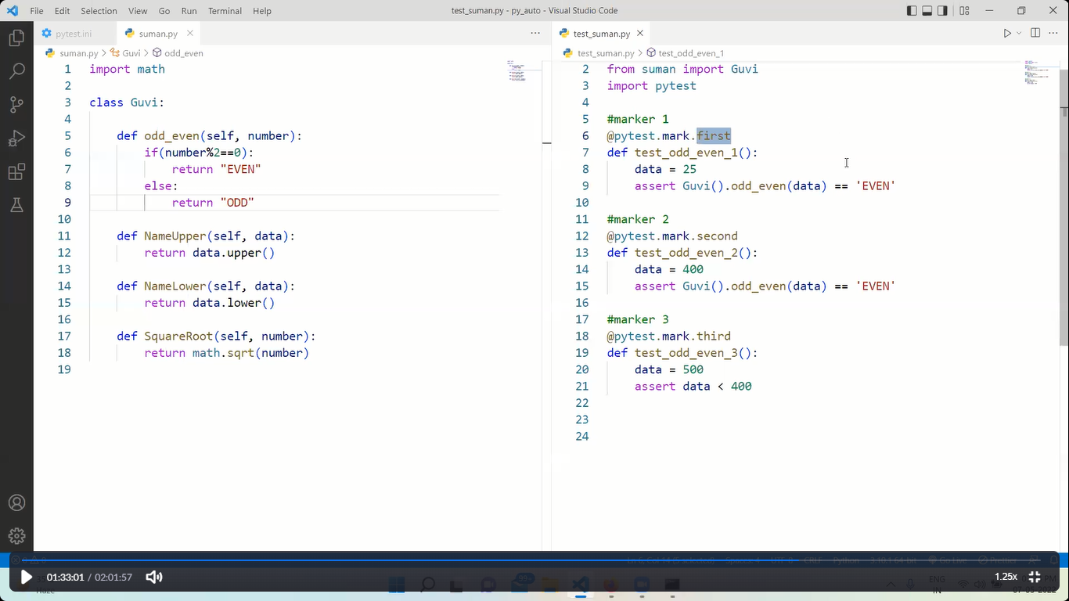

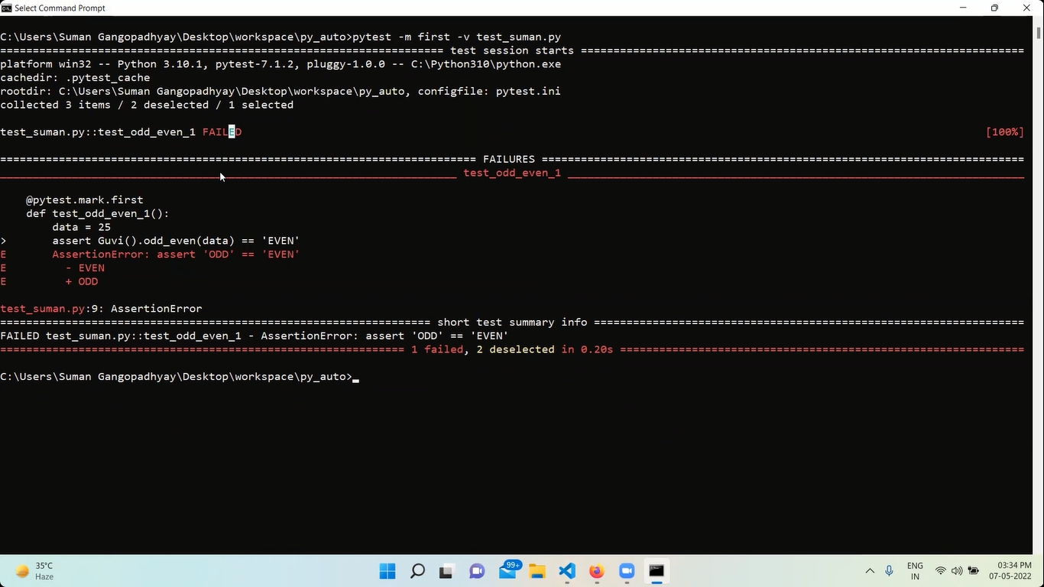

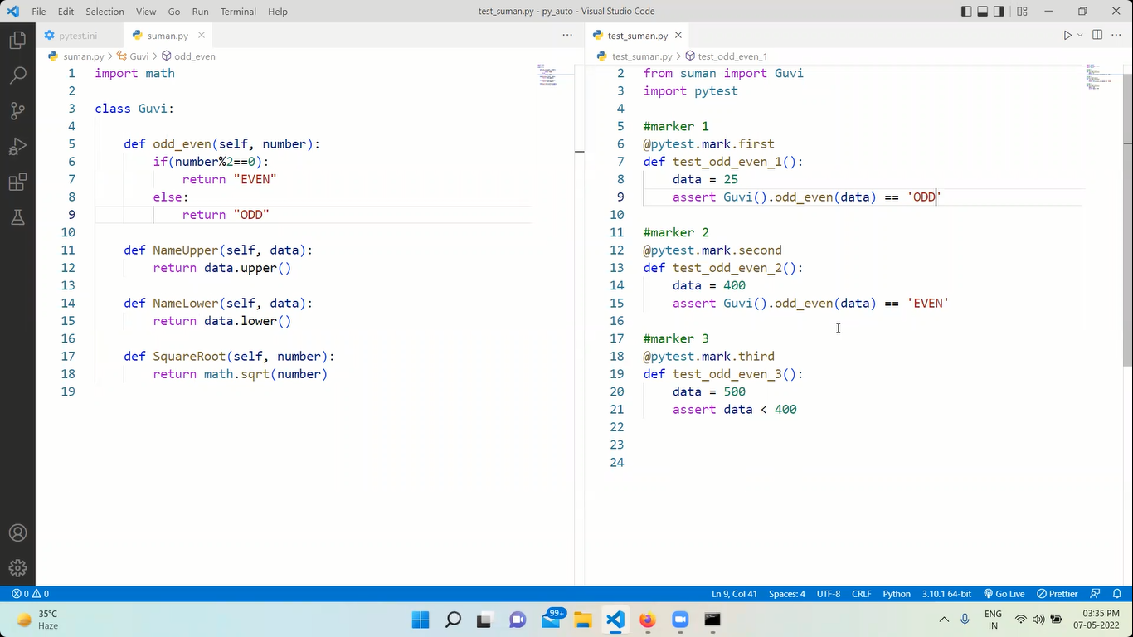

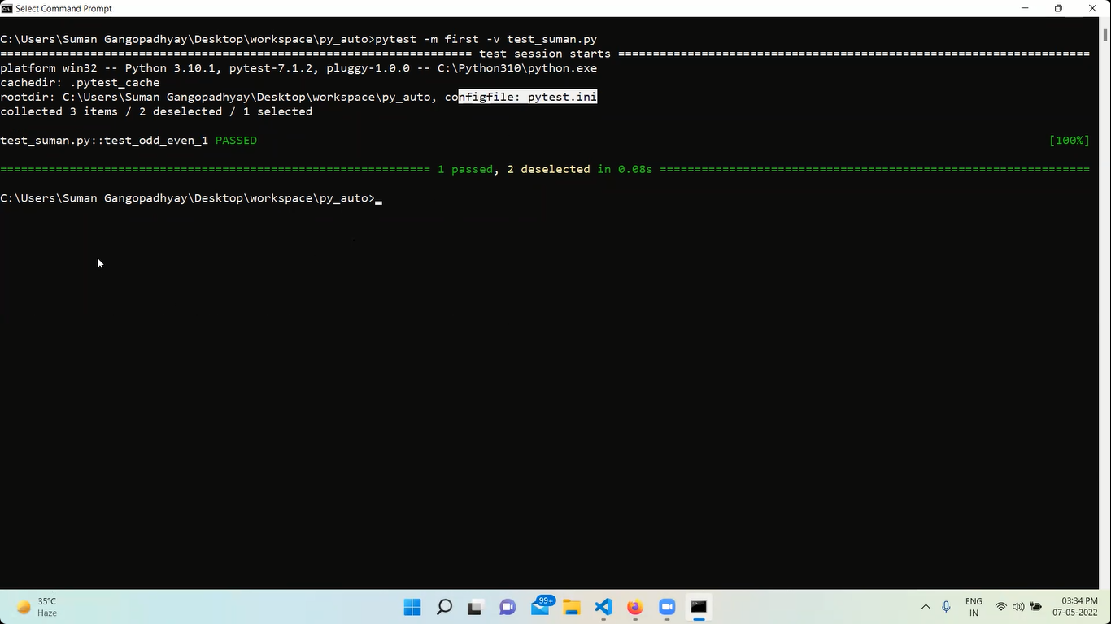

***************************************************************

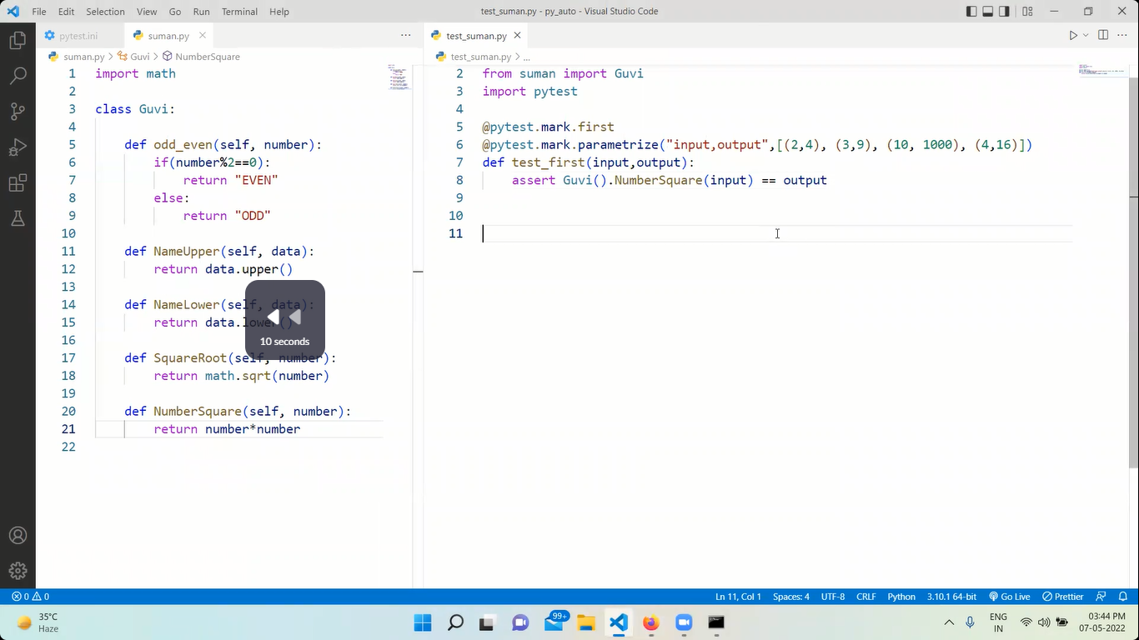

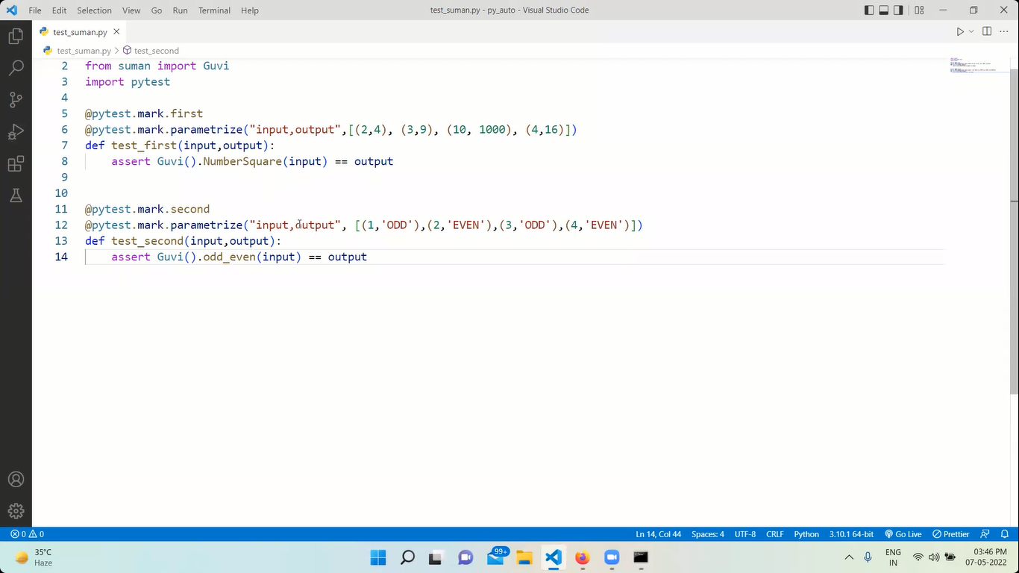

The above is nothing but running different test using different values in a single line

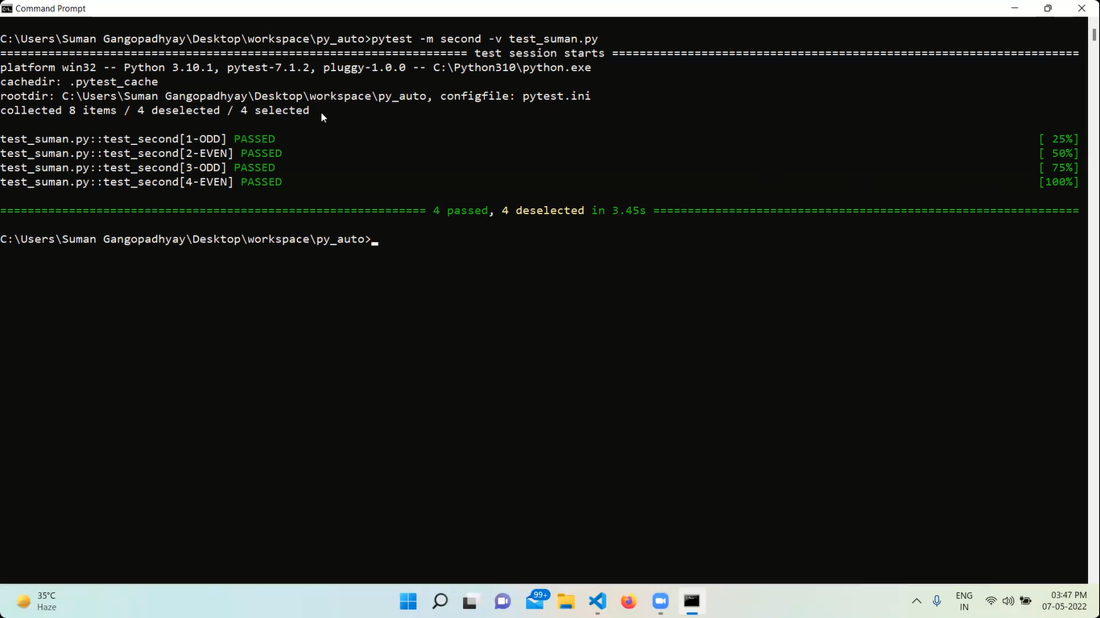

**********************************************

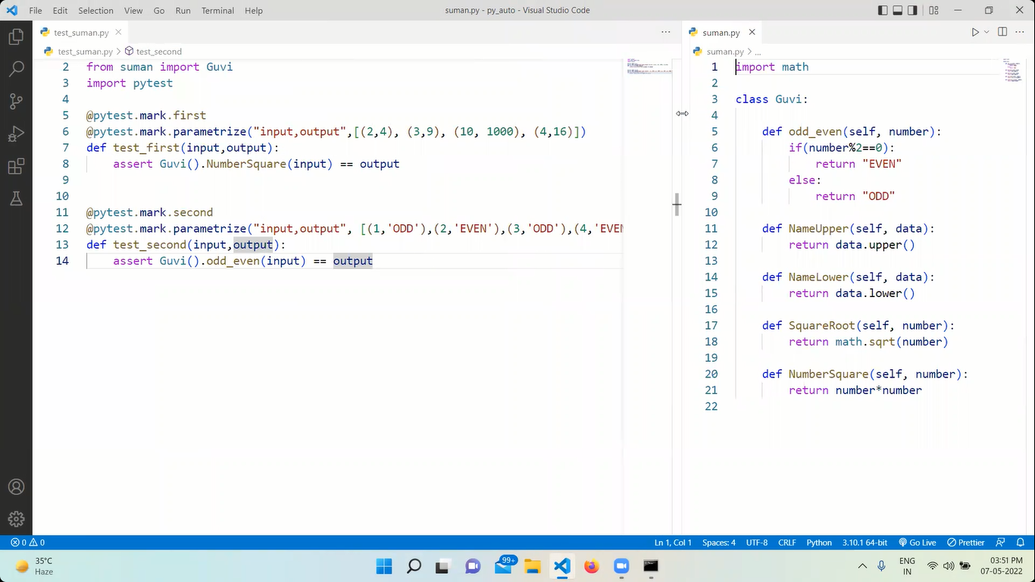

*********************************************.

pytest -m second -v test_suman.py

means second marker will be tested from suman.py file

@pytest.____ --🡪 are generators

Python generators vs python function?